Attachment 3.
Preliminary Round Submission Template
Compound Submission Template:
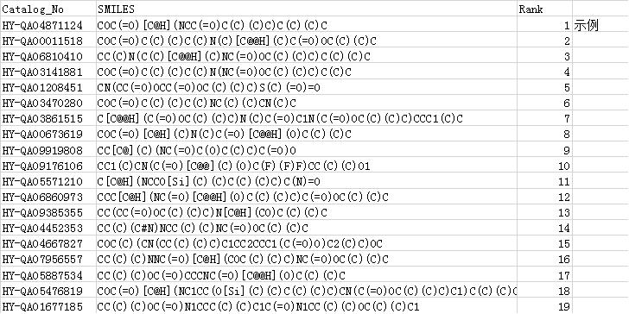
Antibody Submission Template:
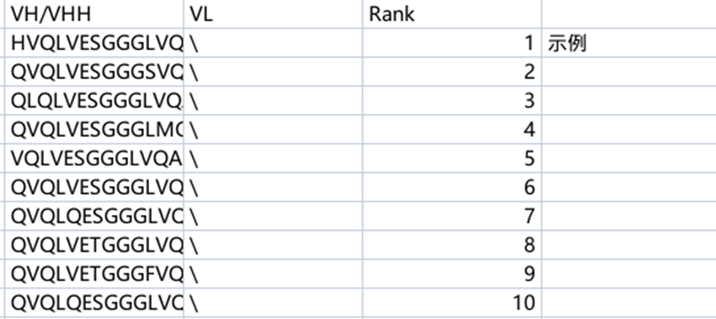

For nanobodies, only the VHH sequence is required; for scFv antibodies, both VH and VL sequences are required.

